27.15: a) 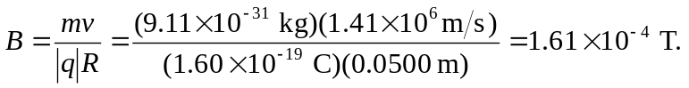
The direction of the magnetic field is into the page (the charge is negative).
b) The time to complete half a circle is just the distance traveled divided by the velocity:
